Contents

Acknowledgements 1

I. Introduction: 2

1. I want to build an RPG game : 2

2. Game Engine: 2

3. Methodology : 2

• Pre-production: 2

• Production: 2

• Post-production: 2

• Operations: 3

4. Unity Learn: 3

II. Pre-production: 6

1. 6

III. Production: 7

IV. Post-production: 8

V. Operations: 9

VI. Conclusion: 10

# Acknowledgements

Mini-RPG game

# Introduction:

## I want to build an RPG game :

RPG stands for role-playing-game , a game in which players take on the roles of imaginary characters and go for adventures.In my game dev project I will start from ‘I want to build an RPG game’ a high level statement.a project design document is provided as well(HeroDesignPrim.docs).

## Game Engine:

Unity will be the choice of 3d real-time game engine.

* Loads of documentations and support threads.
* Loads of free assets for commercial use.
* Free* (with a yearly revenue cap).

## Methodology :

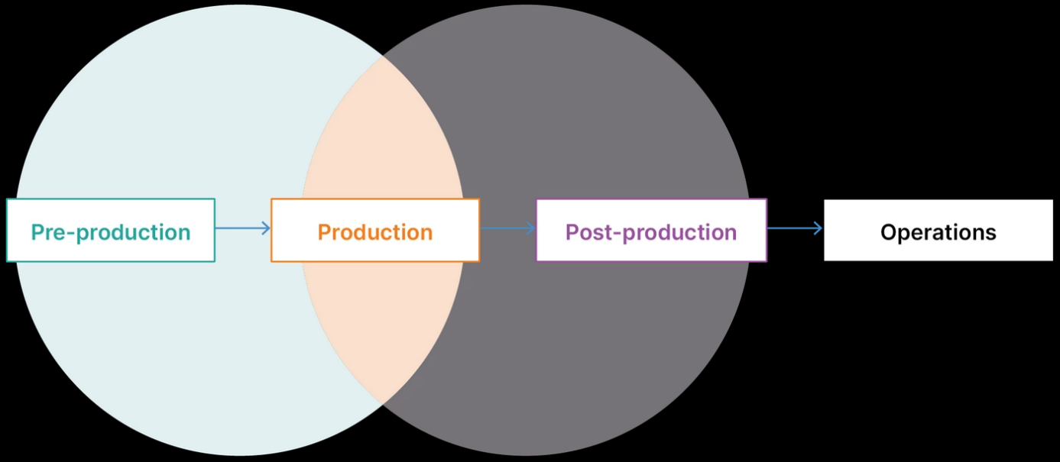

It is consisted mainly of 4 phases of production:

### Pre-production:

planning, prototyping and initial designs. Scrum Style: backlog +sprints planning.

### Production:

creation of the product and assets ,user interfaces ,gameplay ,it is the important and largest part. It will be based on Kanban agile method.

### Post-production:

quality assurance (QA), editing, testing, bug fixing, and final polishing.

### Operations:

sales, monetization, updates(going through pre-production again), and continued maintenance.

## Unity Learn:

Unity Essential Pathway : 2 weeks duration: 1🡪15 Mars 2021

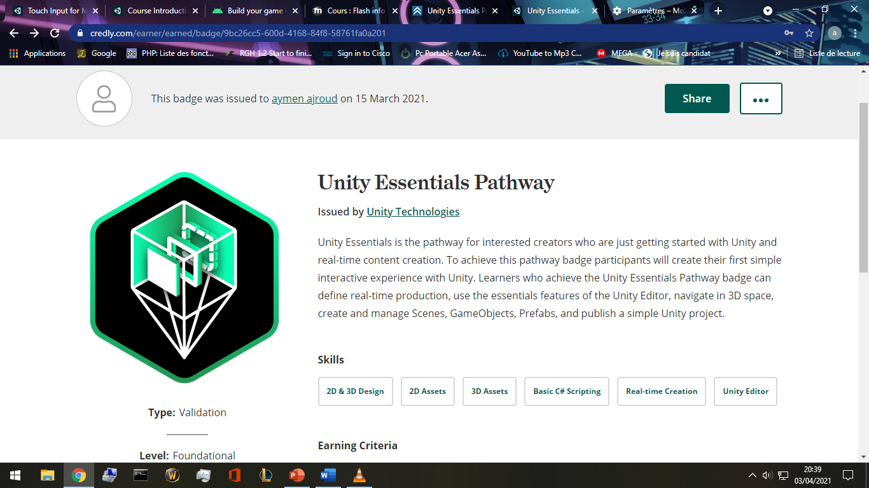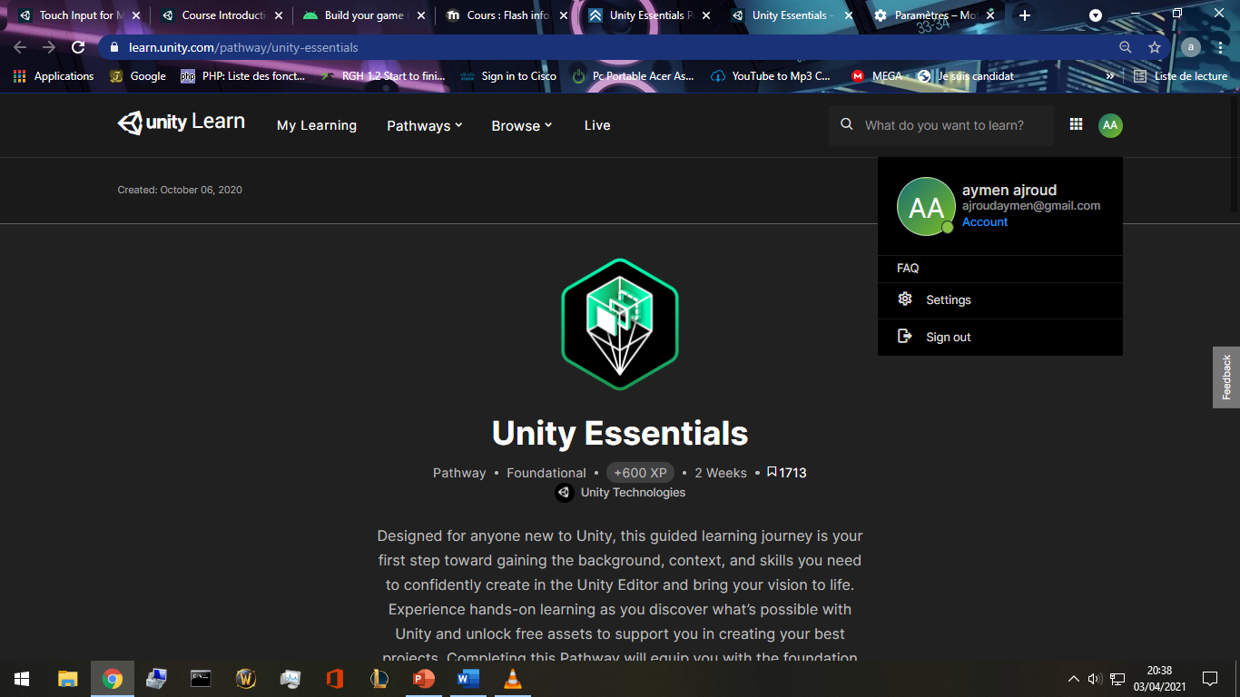<https://learn.unity.com/pathway/unity-essentials>

[https://www.credly.com/badges/9bc26cc5-600d-4168-84f8- 58761fa0a201/public_url](https://www.credly.com/badges/9bc26cc5-600d-4168-84f8-%2058761fa0a201/public_url)

* Unity Junior Programmer: 15🡪29 Mars 2021:

<https://learn.unity.com/pathway/junior-programmer>

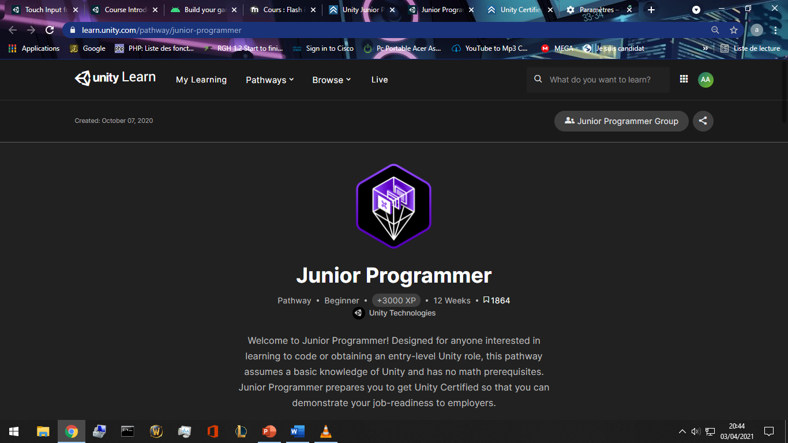

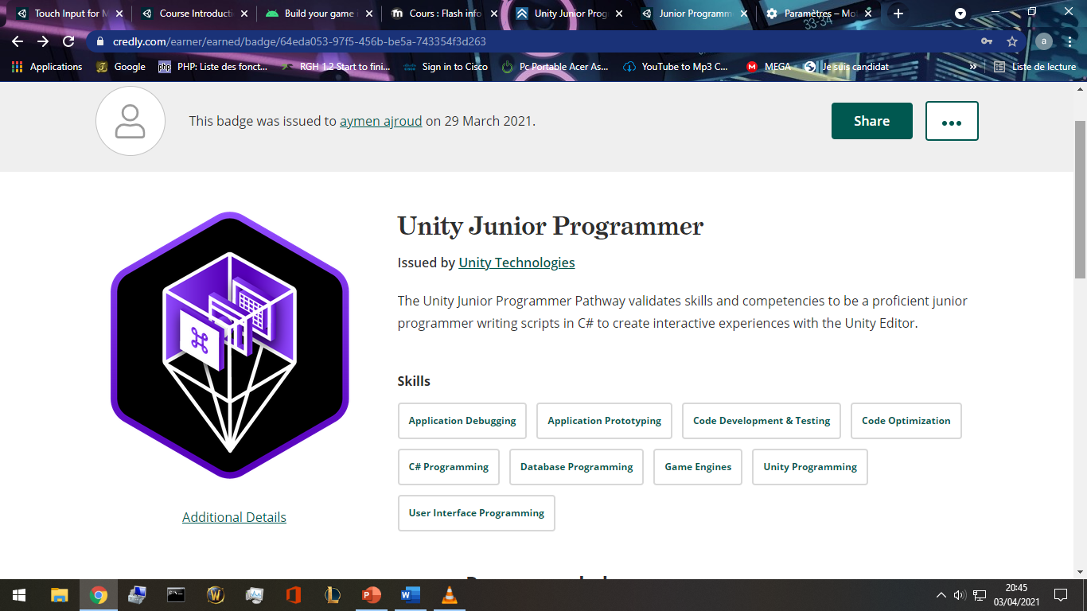<https://www.credly.com/badges/64eda053-97f5-456b-be5a-743354f3d263/public_url>

* *Why Unity game engine:*
* Full of license-free assets : <https://assetstore.unity.com/account/assets>.
* Rich documentation :a huge online manual, <https://docs.unity3d.com/Manual/index.html>
* a huge communities with tons of threads and debugging: forum.unity.com ,
* blogs.unity3d.com, reddit.com.
* C# base coding language.
* Real-Time testing :I can run the game whenever I want using the editor built in
* real-time emulator along with a “Profiler” that calculate frames, resources consumption, all technical info , all for the cause of optimization.
* Workstation and tools:
* Motherboard: H310M PRO-VD PLUS
* CPU: intel i5 9400F 2.9 GHz
* GPU: Nvidia GeForce GTX 1650
* Screen: 32” Vega Led
* Microsoft office suite validated with the institute office 365 email [aymen.ajroud@sousse.r-iset.tn](mailto:aymen.ajroud@sousse.r-iset.tn) .
* Umlet: a powerful diagram designer and freeware.
* SketchBook: a freeware and easy to use image editor.
* Unity editor 2020.3.5f1 LTS
* Blender
* GitHub student pack: GitHub pro.activated by applying with institute email. With GitHub pro student pack I have access to more then hundred hosting/storage/databases and many more services on 3rd party providers like Microsoft azure student pack, canva.com , digital ocean,… <https://education.github.com/pack>
* Firebase.google.com , free basic plans for start ups, cloud storage, Realtime database NoSQL , statistics , web hosting, user authentication .Easy and documented implementation with unity projects.
* Hundreds of free assets in unity assets store for commercial use.

# Pre-production:

## BrainStorming:

I’ve spent 3 days writing down any idea I think of,at any time, and anywhere.

* Level system with experience points.
* With/without level cap.
* Stamina (hp), scalable with items/level
* Multiplayer
* Offline solo
* Openworld
* Stages , each stage have small map, stage=scene.
* Classes like warrior rogue mage priest
* Resources like mana rage energy
* Casting skills/spells
* Talent points tree
* Achievements system
* Google play implementation
* Guest login/ linking account
* Skills and spells upgradable
* Money system (gold , coins, gems,)
* Storyboard (implementing a manga/anime…)
* Characters to start with(female/male) race humain/other imaginairies.
* Quest/reward system.
* Npc (NonPlayerCharacters) quests, trading (sell buy).
* Inventory system
* Character equip system
* Character stats interface
* Enemies to kill (drop items/money/experience/quests requirements).
* Moving touch pad, spells/skills button list
* Free look button
* Swipe to fast cast spells/skills
* duel with other players with pvp reward system
* daily + weekly quests
* 2 or more factions to join
* Guild system
* Messaging system/mail box
* Compare achievements with others in a scoreboard
* Items with levels and rarity
* Fixed view
* Customized view
* Options interface (menu quit volume graphic quality)
* Mini map
* Customizing the controls size/visibility/position
* Pets that follow you and help attack
* Compagnions that can equip items and use skills.
* Crafting tab: salvage items and create higher lvl ones.
* Tap enemies to attack
* Payment ui.
* Googleplay plugin
* Global/guild/party chat system
* Party with friends and play together

## Scooping a similar game: Eternium

* I really like the gameplay but it feels like I hit the Wall where the Grind begins and nothing else other than running endless Trials is progress. Crafting Items isnt worth it cause i need Set/Named items. And there is nothing else to farm other than CL, everything else will drop or wont. *Reddit.com/*
* **Eternium** is an amazingly fun and beautifully crafted Action RPG, reminiscent of the **great** classics. **Eternium** stands out from other mobile Action RPGs by its effortless “tap to move” and innovative “swipe to cast” controls, and its player-friendly “no paywalls, never pay to win” philosophy. *Amazon.in/*

*\*\*google playstore reviews\*\**

* Stats decrease when u lvl up , why not increased? lacking joystick support.
* Upgrade skills by gems instead of skill points. Sorta of pay to win.
* No stamina/energy to limit gameplay.
* Old graphics
* The concept to draw lines to use items/cast spell or skill is innovative.
* Low experience gain rate.
* Grinding for items.
* Free play, don’t have to daily check in.
* No blood or gore so all ages are welcome.
* Small font and bad resolution compatibility on some phones.
* No too easy where it becomes boring.
* Returning to a level and grinding again and again for experience with same story dialogues showing is boring.
* Bad item drop rate
* Progression for new characters are slow.
* Problem with the crafting tab user interface UI.
* Pvp(player-vs-player) is unbalanced, matching players gear is bad.
* Interactive support in google playstore review section.

## Filtering the brainstorming ideas based on available resources and scooping:

* Level system with experience points.
* With~~/without~~ level cap.
* Stamina (hp), scalable with items/level
* ~~Multiplayer~~
* Offline solo
* OpenWorld
* Stages , each stage have small map, stage=scene.
* ~~Classes like warrior rogue mage priest~~
* Resources like mana rage energy
* Casting skills/spells
* Talent points tree
* Achievements system
* Google play implementation
* Guest login/ linking account
* Skills and spells upgradable and unlockable by lvling up
* Money system (gold , coins, gems,)
* Storyboard (implementing a manga/anime…)
* Characters to start with(female/male) race humain~~/other imaginairies.~~
* Quest/reward system.
* Npc (NonPlayerCharacters) quests, trading (sell buy).
* Inventory system
* Character equip system
* Character stats interface
* NPC Enemies to kill (drop items/money/experience/quests requirements).
* Moving touch pad, spells/skills button list
* Free look button
* Swipe to fast cast spells/skills
* ~~duel with other players with pvp reward system~~
* daily + weekly quests
* ~~2 or more factions to join~~
* ~~Guild system~~
* Messaging system/mail box
* Compare achievements with others in a scoreboard
* Items with levels and rarity
* Fixed view
* ~~Customized view~~
* Options interface (menu quit volume graphic quality)
* Mini map
* Customizing the controls size/visibility/position
* ~~Pets that follow you and help attack~~
* ~~Compagnions that can equip items and use skills.~~
* ~~Crafting tab: salvage items and create higher lvl ones.~~
* ~~Tap enemies to attack~~
* Payment ui.
* Google play plugin
* Global/guild/party chat system
* ~~Party with friends and play together~~

## Story+plot:

A hero came to save the village from skeletons, take quests, gather, kill , find, and return for exp and glory.

## Core mechanics:

* player can move freely.
* Talk to npcs in the village for questing.
* Attack goblins.
* Find stolen items.
* Gather herbs.

## Game Play:

1st u choose between a male/female character,then u spawn beside a village. You can move freely in the open world. Kill threatening skeletons ,find rare items, collect herbs for quests to earn exp and lvl up.

## Music/sound:

A calm music running in background.

## Art style:

Medieval style of sword and magic.free assets from unity strore.

|  |  |  |  |
| --- | --- | --- | --- |
| Project Concept | | | |
| 1 **Player Control** |  | You control a   |  | | --- | | *A male/female character* | | in this   |  |  | | --- | --- | | *Top down view* | game | |
|  | where   |  | | --- | | *The touch pad+buttons* | | makes the player   |  | | --- | | *move run attack* | |

|  |  |  |  |  |  |  |
| --- | --- | --- | --- | --- | --- | --- |
| 2 **Basic**  **Gameplay** |  | During the game,   |  |  | | --- | --- | | *Enemies/friendly npcs* | appear | | from   |  | | --- | | *Moving around the open world stage* | |
|  | and the goal of the game is to   |  | | --- | | *Complete missions, earn money, upgrade skills and leveling up* | | |

|  |  |  |  |  |  |
| --- | --- | --- | --- | --- | --- |
| 3 **Sound**  **& Effects** |  | There will be sound effects   |  | | --- | | *when moving, attacking, dying, enemy dying, friendly npcs talk* | | and particle effects   |  | | --- | | *when Dying, moving, finishing quests, leveling up* | |
|  | [*optional*] There will also be   |  | | --- | | *All characters have basic animation effect.* | | |

|  |  |  |  |  |  |
| --- | --- | --- | --- | --- | --- |
| 4 **Gameplay**  **Mechanics** |  | As the game progresses,   |  | | --- | | *Enemy level increases, quests rewards increases, experiencee needed to lvl up increases, talent points* | | making it   |  | | --- | | *Scallable* | |
|  | [*optional*] There will also be   |  | | --- | | *when you die, you need to watch an ad video or wait ? minutes to respawn* | | |

|  |  |  |  |  |  |  |  |
| --- | --- | --- | --- | --- | --- | --- | --- |
| 5 **User**  **Interface** |  | The   |  | | --- | | *Money* | | will   |  | | --- | | *Increase* | | whenever   |  | | --- | | *loot enemies/sell items* | |
|  | At the start of the game, the title   |  |  | | --- | --- | | *hero* | will appear | | | and the game will end when   |  | | --- | | *Doesn't end,level cap, dangeons, bosses, loot, items.* | |

## Project Timeline

|  |  |  |
| --- | --- | --- |
| Milestone | Description | Due |
| **#1** | |  | | --- | | * *Menu/start/quit ui + 1st stage+controls+characters+npc+ennemies+deploy to googleplay store* | | |  | | --- | | *29/04* | |
| **#2** | |  | | --- | | * *log in functionality+google play integration+back end server+databases* | | |  | | --- | | *29/05* | |
| **#3** | |  | | --- | | * *optimization+adding more features +ads+billing system* | | |  | | --- | | *15/06* | |
| **#4** | |  | | --- | | * *more code optimization+release of more stages.+facebook page+advertizing* | | |  | | --- | | *30/06* | |

## Class Diagram:

## Optimization:

When developing, optimization should come naturally while coding,here are some tips for RPG kind of games:

* Reduce the music/audios format to keep it light.
* Compress/reuse textures.
* Remove unused assets items.
* Smaller games are faster to download and require less data on initial install, and eventually higher install conversions.Texture compression formats.
* Reduce events number in a scene.
* Reduce/re-use effect plugins (lightning, sounds, particles [or anything that includes "advanced" physics], etc.).
* Support 64-bits architectures.
* Use unity profiler and analyze game performance/requirements.
* Clean code.
* Always add comments.
* Keep it simple.
* Static batching (static objects reduce hugely resource consumption, so whenever an object doesn’t move, make it static).
* Dynamic batching (combine meshes ).
* Culling to limit what’s rendering (Imagine standing in front of a door and still rendering all objects behind that door. This is where Occlusion Culling comes in).
* Reducing physics computing (It's important to note that having too many Rigidbody objects within your game will affect performance negatively.)
* Object Pooling(Pooling commonly used objects allows you to reuse them over and over again without destroying them).
* Coroutines/update(update will happen every frame, so coroutines sometimes reduce a lot of work).
* Cashing Components(for example Don't use GetComponent multiple times in a method when you can cache it once and use that variable throughout the script.).
* Better to manually assign objects in the script component then using the gameobject.find().
* if you're not using something, turn it off.
* in general you should use the minimum amount of lights necessary to achieve your desired style.
* Enable Instancing option within unity.

## Chosen assets:

|  |  |  |
| --- | --- | --- |
|  | <https://assetstore.unity.com/packages/3d/characters/humanoids/girl-with-clothes-worker-set-162925> | A female villager with idle animation only |
| screenshot | <https://assetstore.unity.com/packages/3d/characters/humanoids/fantasy/oriental-fantasy-character-berserker-grade-0-171147> | Female hero with animations |
| screenshot | <https://assetstore.unity.com/packages/3d/characters/humanoids/humans/fantasy-chess-rpg-character-arthur-160647> | Male Hero with animations |
| screenshot | <https://assetstore.unity.com/packages/2d/gui/fantasy-wooden-gui-free-103811> | Ui materials |
| screenshot | <https://assetstore.unity.com/packages/3d/environments/nature-starter-kit-2-52977> | Nature kit 3d |
|  | <https://assetstore.unity.com/packages/3d/characters/humanoids/fantasy/rpg-skeleton-35463> | Skeleton 3d with animations |
|  | <https://assetstore.unity.com/packages/2d/gui/icons/basic-rpg-icons-181301> | Basic rpg game icons |
|  | <https://assetstore.unity.com/packages/3d/environments/fantasy/fantasy-forest-environment-free-demo-35361> | Trees/bush 3d prefabs |
| screenshot | <https://assetstore.unity.com/packages/tools/version-control/github-for-unity-118069> | GitHub unity plugin |

## Initial BackLog: Sprints and tasks in priority order:

* UI: user interface, login/link interface (dead buttons), support, faq,
* Building initial map
* Graphic settings interface
* Inventory system
* Equip system
* Controls: player input, touch pad.
* Hero stats
* Building villagers,npcs,quest lines.
* Environment details,map details.

# Production:

# Post-production:

# Operations:

# Conclusion: